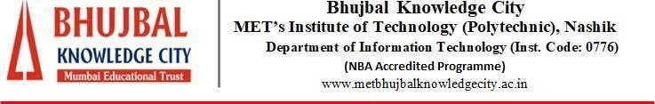


MAHARASHTRA STATE BOARD OF TECHNICAL EDUCATION –
MUMBAI

Academic Year 2025-26

MET’S INSTITUTE OF TECHNOLOGY - POLYTECHNIC

BHUJBAL KNOWLEDGE CITY, ADGAON, NASHIK

A
Micro-Project Report On

“WEB PAGE DESIGNING”
Submitted by,

Tanmay Sachin Bhalerao (05)

Guided by, Mr. C. S. Mogare
Lecturer
Department of Information Technology



CERTIFICATE
This is to Certify that this report,

“WEB PAGE DESIGNING”
Submitted by,

Tanmay Sachin Bhalerao (05)
Enrollment No:25611470404
Seat No:447041
The student of First Year Information Technology Department
In the academic year 2025-26,
As a part of the Self-Learning Assessment Work prescribed by the
Maharashtra State Board of Technical Education (MSBTE), Mumbai.
I have guided them for the said work from time to time and found them satisfactorily progressive.
The said work has been assessed by me
And is found to meet the standards envisaged for the level of the course.

Mr. C. S. Mogare | Mr. G. A. Parbhane | Dr. R.S. Narkhede
Micro Project Guide | Head of Department | Principal

ACKNOWLEDGEMENTS
We take this opportunity to express our deepest sense of gratitude and sincere thanks to those who have helped us in completing this task.

We express our sincere thanks to our Project Guide Mr. C. S. Mogare, Information Technology Department, who has given us excellent guidance, continuous Encouragement for the completion of this work. His kind assistance and constant inspiration will always help us in our future also.

We are very thankful to Head of Department Mr. G. A. Parbhane for encouraging us to undertake this project and he has taken keen interest in making the project and report absolutely flawless.

We are very thankful to Principal. Dr. R.S. Narkhede, for encouraging us to undertake this project and he has taken keen interest in making the project and report absolutely flawless.

VISION AND MISSION STATEMENT

Vision Statement of Department of Information Technology:

To develop competent IT engineers with enhanced knowledge, skills and professional attitudes to suit the changing scenario and to serve techno-social needs.

Mission Statement of Department of Information Technology:
M 1 : To implement teaching-learning processes for the spreading the knowledge of fundamental engineering and emerging trends .
M 2 : To adapt teaching practices to meet the needs of the IT industry and society.
M 3 : To inculcate the sense of social responsibility among learners.

MICRO PROJECT REPORT

- Introduction
Web Page Design is used to develop online applications for various organizations such as organizational and educational websites, virtual learning environments, business applications in various fields such as products, sales, banking railways reservation, services etc. Web pages are categorized into two namely: static and dynamic webpage. This course introduces web page design using HTML5 and also gives emphasis on learning Cascading Style Sheets (CSS) which is a style sheet language used for describing the presentation of a document written in a markup language for formatting and styling of content.
- Aim of the Micro-Project
Develop and host the static website as per industry requirement.

  - Course Outcomes Integrated
    - CO1 - Use HTML formatting tags to present content on web page.
    - CO2 - Develop web page using list and hyperlinks.
    - CO3 - Develop web pages using images, colors and backgrounds.
    - CO4 - Design HTML forms using table and frames.
    - CO5 - Apply presentation schemes on content using CSS.
    - CO6 - Publish websites on internet or intranet
  - Action Plan
Website Designing steps:
    - Designing a website from scratch can seem overwhelming, but it becomes manageable if you break it into steps. Here’s a beginner-friendly guide:

UNDERSTAND YOUR GOALS:
  - Purpose: What is the website for? (e.g., portfolio, blog, e-commerce)
  - Audience: Who is it for? (e.g., professionals, customers, friends)
  - Features: What do you want to include? (e.g., contact forms, images, articles, products)

PLAN YOUR CONTENT:
  - Make a list of pages you'll need, such as:
    - Home
    - About
    - Services/Products
    - Blog/News
    - Contact

CHOOSE A WEBSITE-BUILDING METHOD:

No-Code Platforms:
    - Use tools like Wix, Squarespace, or WordPress.com for drag-and-drop simplicity.

Low-Code Platforms:
    - Use WordPress.org or similar platforms with customizable templates.

Code it Yourself (for more control):
    - Learn basics of HTML, CSS, and JavaScript.

SELECT A DOMAIN AND HOSTING:
  - Domain: Your website’s name (e.g., mysite.com). Purchase it from providers like GoDaddy or Namecheap.
  - Hosting: Where your site is stored online (e.g., Bluehost, HostGator, SiteGround).

DESIGN YOUR WEBSITE:

Choose a Theme/Template:
    - Platforms like WordPress or Wix offer templates you can customize.

Use Design Principles:
    - Consistency: Keep fonts, colors, and layouts uniform.
    - Navigation: Make menus easy to understand.
    - Visual Hierarchy: Highlight important elements (e.g., headings, buttons).

Colors and Fonts:
    - Use tools like Coolors.co for color schemes.
    - Google Fonts offers free fonts.

ADD FEATURES:
  - Images: Use tools like Canva to create/edit images.
  - Forms: Add contact or feedback forms.
  - SEO Optimization: Use tools like Yoast SEO to help your site rank on Google.

TEST AND LAUNCH:
  - Test your website on different devices (mobile, tablet, desktop).
  - Check links and forms to ensure they work.
  - Launch the site.

MAINTAIN AND UPDATE:
  - Update content regularly.
  - Monitor performance using tools like Google Analytics.
  - Fix broken links or outdated information.

Sr.  No. | Details of activity | Planned Start  date | Planned  Finish date
1 | Create Google drive folder for WPD save all Practical’s and output screenshot | C2:17/12/2025 | C2:31/12/2025
2 | Develop web page for family tree using list and add hyperlinks for MSBTE website | C2:31/12/2025 | C2:07/01/2026
3 | Develop web page for FYIF Time table using images, colors backgrounds and CSS | C2:07/01/2026 | C2:11/02/2026
4 | Design HTML forms. | C2:11/02/2026 | C2:18/03/2026
5 | Create a website and host on open source | C2:18/03/2026 | C2:25/03/2026

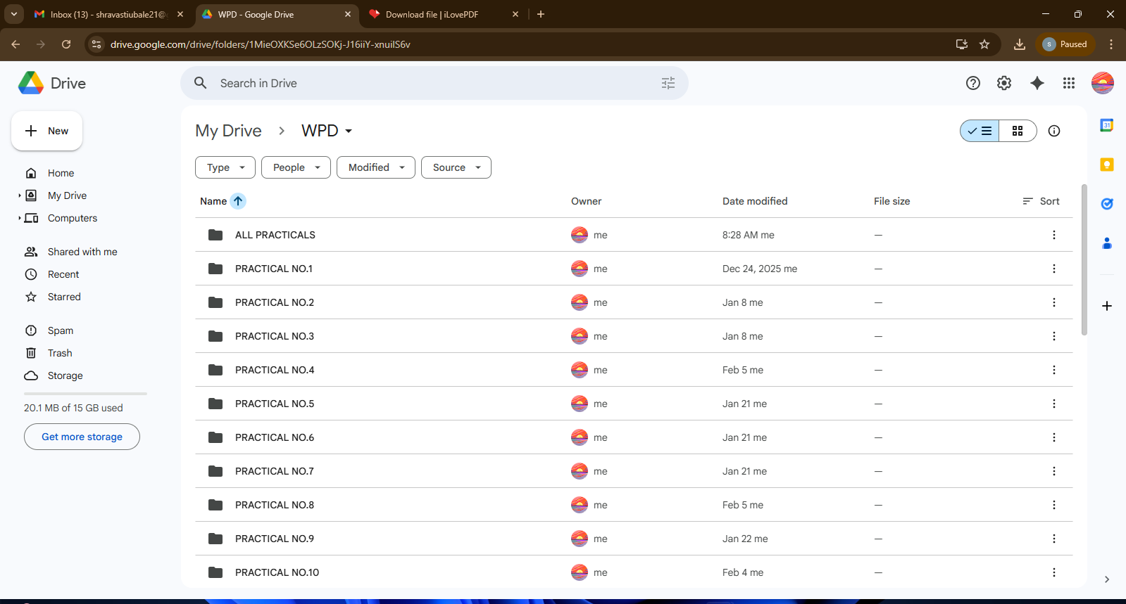
5.0 Resources Required:

Sr. No. | Name of Resource/material | Specifications | Qty | Remarks
1 | Computer system | Windows 11 | 1 | -
2 | Designing webpage, Introduction of html | https://www.w3schools.com/html/html  _blocks.asp | - | -
3 | Block Level Tag | https://www.geeksforgeeks.org/ | - | -
4 | Frames in HTML | https://www.javatpoint.com/html- frame-tag
5 | CSS Style sheet ,CSS Advanced | https://www.w3schools.com/css/defaul t.asp
6 | References for AI & Machine Learning | https://www.javatpoint.com/machine- learning | - | -
6.0 Output of Micro Project:
Task1: Create Google drive folder for WPD save all Practical’s and output screenshot

Task2: Develop web page for family tree using list, DIV tag, CSS and add hyperlinks for MSBTE website.

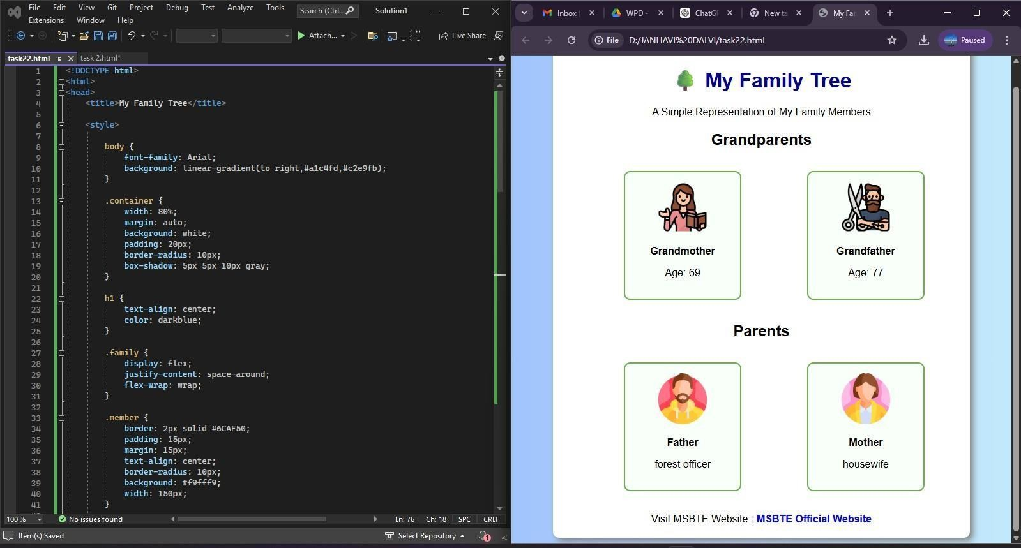

Task3: Develop web page for FYIF Time table using images, colors backgrounds and CSS
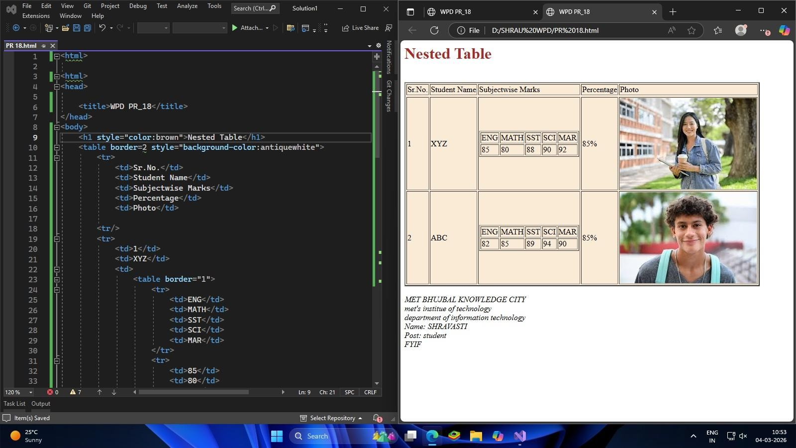

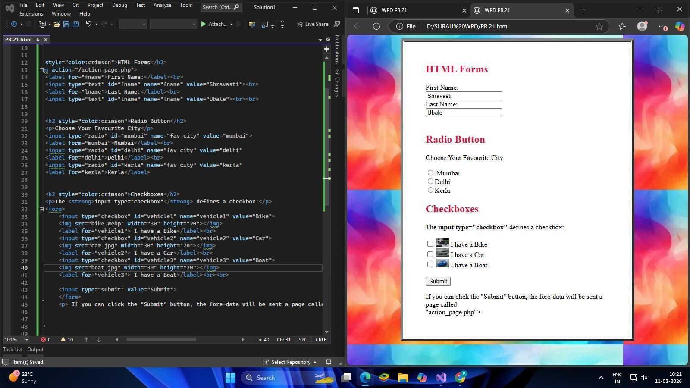
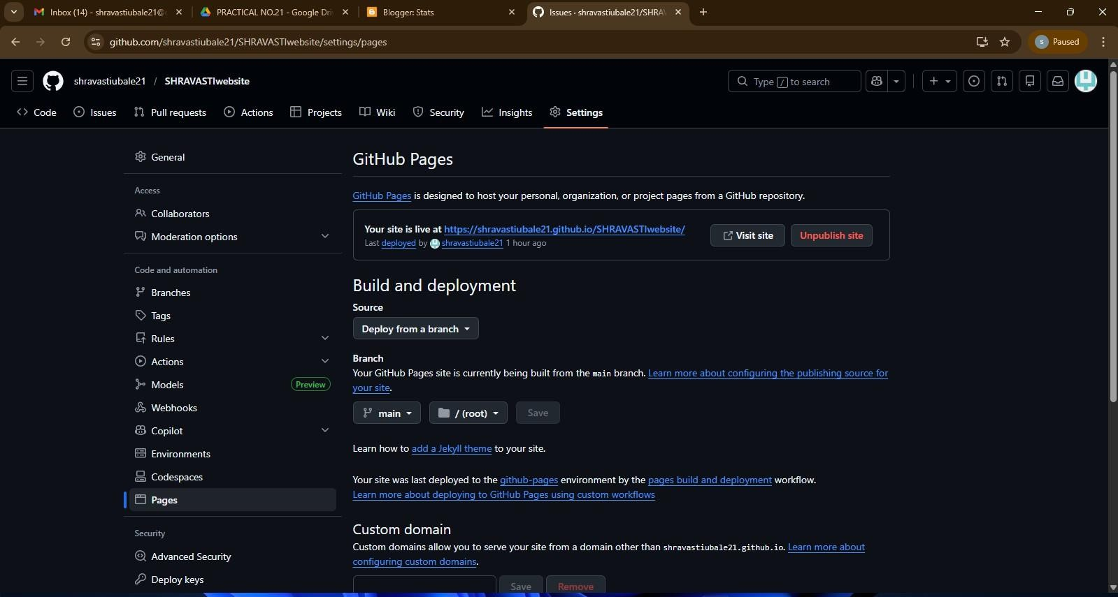
Task4: Design HTML forms.

Task5: PartA:-Create a website and host on open source

-

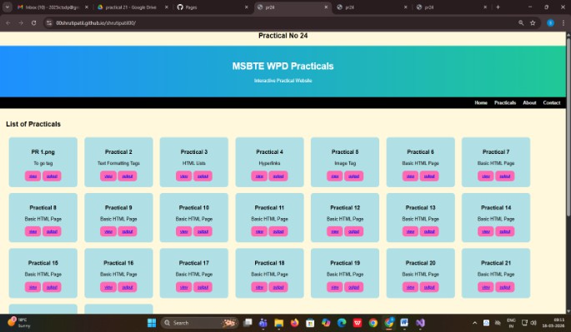
Task5: Part B:-Add print of website.

  - Skill Developed / learning out of this Micro-Project

    - Use HTML formatting tags to present content on web page.
    - Develop web page using list and hyperlinks.
    - Develop web pages using images, colors and backgrounds.
    - Design HTML forms using table and frames.
    - Apply presentation schemes on content using CSS.
    - Publish websites on internet or intranet.


Teacher Evaluation Sheet

Name of Student: Tanmay Sachin Bhalerao Enrollment No.: 25611470404
Name of Department: Information Technology Semester: Second Course Title: Web Page designing Code: 312004 Title of the Micro-Project: Web Page designing Seat No.:447041

Course Outcomes Achieved:
    - Use HTML formatting tags to present content on web page.
    - Develop web page using list and hyperlinks.
    - Develop web pages using images, colors and backgrounds.
    - Design HTML forms using table and frames.
    - Publish websites on internet or intranet

Micro-Project Evaluation Sheet

Roll No | Enrollment No | Exam Seat Number | Name of the Student | SLA Activities |  |  |  |  | SLA Marks according to L-A Scheme (Max Marks 25)
Micro project/ Assignments/ Other Activities for specific learning
(out of 05)
1 | 2 | 3 | 4 | Task1 | Task2 | Task3 | Task4 | Task5 | 7
39 | 25611470404 | 447041 | Tanmay Bhalerao

Comments/Suggestions: (if any)
………………………………………………………………………………………………………………………………………………
………………………………………………………………………………………………………………………………………………
……………………………………………………………………………………………..………………………………………………
………………………………………………………………………………………………………………………………………………

Name and designation of the Faculty Member: Mr. C. S. Mogare (Lecturer)

Signature………………………………

